YAWL Logging/Database Functionality

Engine Methods

This section describes methods which are available from external services, such as custom YAWL Services. All these methods are based on accessing a running engine. They are based on HTTP, and XML.

Accessing past and current workflows

Methods exist for accessing the state of workflows which are or have run in the engine.

A list of all query methods for the engine follows. These methods do not change the state of the engine.

- Interface A
  - Get Users
  - Get List of Specifications
  - Get Services

- Interface B
  - Describe all work items
  - Get children of work item
  - Get Task information
  - Get List of Specifications
  - Get process definition (XML)
  - Get Cases for Specification
  - Get state of case
  - Get Specifications by restriction

The most useful set of operations are found in Interface B

- Describe all work items
Gets the details of all workitems which are currently active in the engine. For historical work item data, the logging tables must be used.
- Get Task information
  - Describes a task in terms of its specification, parameters, attributes, and decomposition.
- Get List of Specifications
  - List all specifications which are currently loaded into the engine
- Get process definition (XML)
  - Retrieves the actual XML specification which was uploaded into the engine
- Get Cases for Specification
  - Retrieves a list of case identifiers for a particular specification
- Get State of Case
  - Returns a description of a case, can be used to access previously run cases as well.
- Get Specifications by restriction
  - Returns a set of specifications based on the restriction query provided to the operation.

Logging data

Logging data is created throughout the execution of various workflows. Logging is created for two categories
- Workitems
- Cases

Workitems
For each transition of a workitem from one state to another, an event is created. This event is linked to a particular task. For each workitem event the following information is stored:
- TaskID
- Event type
- Resource – which resource caused this change
- Time of event
- Description – the specification which this event belongs to
- Identifier

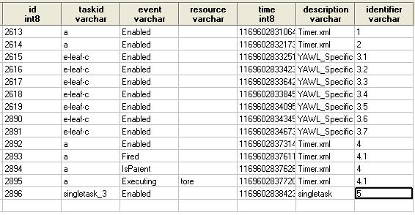

Cases
Case events are created whenever a case is either: started, cancelled or completed. Each case description contains the specification name and the time of creation or completion. If a case was completed normally, the cancelled time is equal to the completed time.
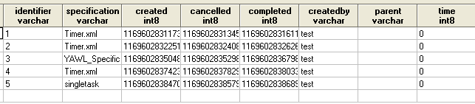

Listening for YAWL Engine Events

Existing listeners
- Hibernate Listener stores the events to the database
- JMS listener sends out JMS events

Creating new listeners

New listeners can be created if desired. This could for example be an email listener which filters out events and notifies of when a case is complete. Other options could be to send out events to another type of storage which could be accessed by applications. It is also possible to send messages directly to an application, so it can monitor all the events in the engine.

The difference between an event listener an a custom YAWL Service, is:
- Events can be sent out to multiple listeners
- In the specification each decomposition can only have one service.
- There are no changes in the specification required to listen for an event
- For a custom YAWL Service to listen for events, it must be specified in the XML file.
- Event listeners are not registered with the engine as other services, although they must be loaded in at start time.

All that is required to define a listener is to create a class which implements interface: au.edu.qut.yawl.events.YEventDispatcher

The class implementing this file can be placed in the tomcat classpath, and defined in the applicationContext.xml file.

Extracting data from the database

Rather than creating a new listener, it is possible to mine the data from the database. This can be done either through a normal SQL/JDBC interface or through Hibernate.

Hibernate

Hibernate can be used to directly create objects based on the database tables. This can be useful to recreate the state of the engine in another application, and the query the various objects.

JDBC/SQL
The simplest way to query the database is through a standard JDBC connection. The database structure is shown at the end of this document. A simple select statement can be used extract log information from the various tables, as well as information regarding various runtime states of the engine.

Database structure
